Physics 30 Lesson 11 Interference of Light

# Light – wave or particle?

That light carries energy is obvious to anyone who has focused the sun's rays with a magnifying glass on a piece of paper and burned a hole in it. But how does light travel and in what form is this energy carried? Energy can be carried from place to place in two basic ways: by **particles** or by **waves**. In the first case, material bodies or particles such as a thrown baseball or the particles in rushing water carry energy – kinetic energy. In the second case, waves like sound or water waves can carry energy over long distances. In view of this, what can we say about the nature of light? Does light travel as a stream of particles away from its source or does it travel in the form of waves that spread outward from the source? Historically, finding a definite answer to this question has turned out to be quite difficult. For one thing, light does not reveal itself in any obvious way as being made up of tiny particles nor do we see tiny light waves passing by as we do water waves.

Sir Isaac Newton experimented extensively with light. He proposed the **corpuscular theory of light** where light consisted of tiny particles called corpuscles (i.e. “little bodies”) that moved through space in straight lines with incredible speed. The great Dutch scientist Christian Huygens (1629 – 1695), a contemporary of Newton, proposed a wave theory of light that had much merit. But so great was Newton’s prestige at the time that the majority of people accepted his view. A key experiment performed in 1801 changed everything.

# The wave theory of light

Huygens (refer to Pearson pages 684 to 685) developed a technique for predicting the future position of a wave front when an earlier position is known. This is known as **Huygens' principle** and can be stated as follows:

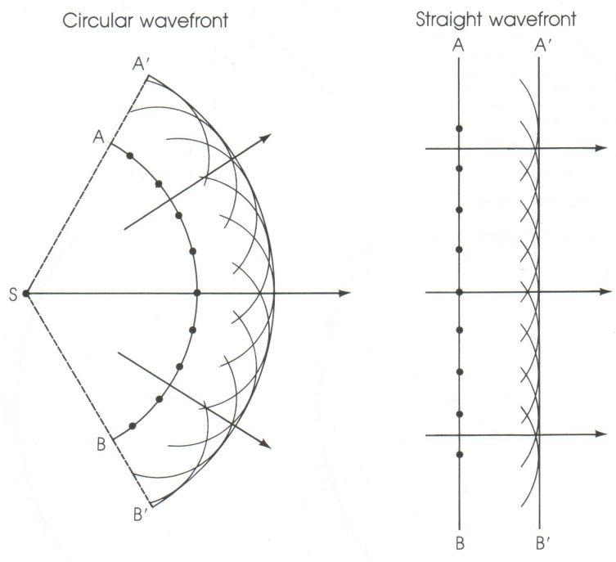*Every point on a wave front can be considered as a point source of tiny secondary wavelets that spread out in front of the wave at the same speed as the wave itself. The surface envelope, tangent to all the wave­lets, constitutes the new wave front*.

As a simple example of the use of Huygens' Principle, consider the circular and straight wave fronts AB at some instant in time as shown to the right. Each point on the wave front AB is the source of new wavelets, seen as a series of small semi-circles. All of the wavelets combine to form the new wave front A'B'.

Huygens' principle is particularly useful when waves impinge on an obstacle and the wave fronts are partially interrupted. Huygens' principle predicts that waves bend in behind an obstacle. The bending of waves behind obstacles into the “shadow region” is known as **diffraction.** Since diffraction occurs for waves, but not for particles, it can serve as one means for distinguishing the nature of light.

Does light exhibit diffraction? In the mid‑seventeenth century, a Jesuit priest, Francesco Grimaldi (1618–1663), had observed that when sunlight entered a darkened room through a tiny hole in a screen, the spot on the opposite wall was larger than would be expected from geometric rays. He also observed that the border of the image was not clear but was sur­rounded by coloured fringes. Grimaldi attributed this to the diffraction of **light**. Newton, who favoured a particle theory, was aware of Grimaldi's result. He felt that Grimaldi's result was due to the interaction of light corpuscles with the edges of the hole. If light were a wave, he argued, the light waves should bend more than that observed. Newton's argument seemed reasonable, yet diffraction is noticeable only when the size of the obstacle or the hole is on the order of the wavelength of the wave. Newton did not know that the wavelengths of visible light were incredibly tiny, and thus diffraction effects were very small. Indeed this is why geometric optics using rays is so successful – normal openings and obstacles are much larger than the wavelength of the light, so relatively little diffraction or bending occurs.

In 1801, a key experiment was performed by the brilliant Thomas Young (1773 – 1829). (Refer to Pearson pages 685 to 690.) Young directed light through two parallel narrow slits a small distance apart. The light was then seen on a screen a few meters away. If light consisted of particles the result would be two bright fringes on the screen as shown on the right.

But the actual results were quite different. Instead of two bright fringes, there were a series of alternating bright and dark fringes. Young reasoned that he was seeing a **wave interference** pattern caused by the **diffraction** of light through each of the slits. Light diffracting through one of the slits interfered with the diffracted light from the other slit.

# Interference of light waves

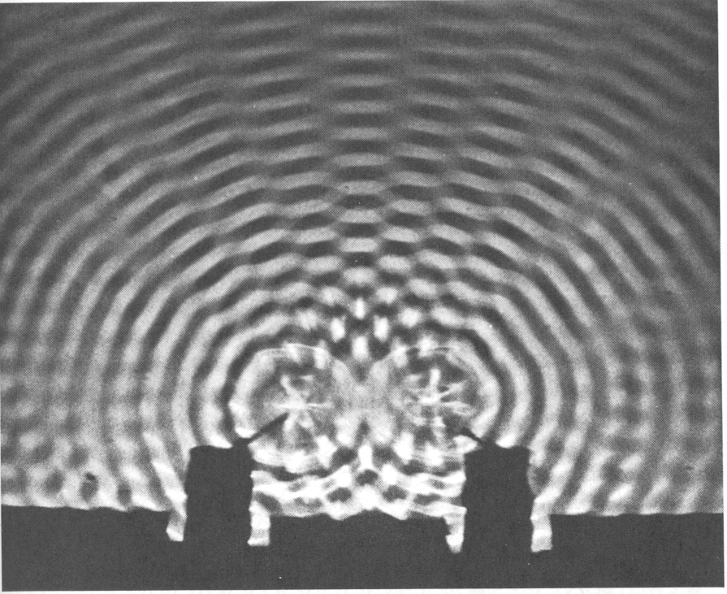

antinodes

nodes

**d**

Recall from Physics 20 that when two waves meet they interfere with each other in an additive fashion. The waves combine either constructively or destructively depending on how they meet. For two-dimensional mechanical waves consider the situation where two sets of waves are being generated at the same time and in the same phase a distance (d) from each other. When crests meet crests and troughs meet troughs, **constructive interference** occurs and these are called **antinodes** or **maxima**. When crests meet troughs, complete **destructive interference** occurs and these are called **nodes** or **minima**. Notice the pattern of antinodes with nodes in between them. (Refer to pages 425 to 428 in Pearson for a discussion of two-dimensional wave interference.) Check out the video clip called **P30 L11 Double source interference** in D2L.

To understand how an interference pattern is produced, consider the diagrams below. Two waves of wavelength  are shown to originate from two vibrating sources (S1 and S2) a distance **d** apart. While waves spread out in all directions, we will focus our attention on the two wave trains shown in each of the following diagrams. In diagram (a) the waves travel the same **path length** – when they meet they are in phase and constructive interference occurs resulting in a maximum or antinode.

S1

S2

a) constructive interference

S1

S2

b) constructive

interference

● (path difference)

There will also be constructive interference if the **path difference** from the wave sources is one wavelength or a whole number multiple of wavelengths (1, 2, 3, n) as shown in diagram (b).

However if the path difference is ½ or 3/2 or 5/2 and so on, the result is destructive interference resulting in nodes or minima as illustrated in diagram (c).

S1

S2

½(path difference)

c) destructive

interference

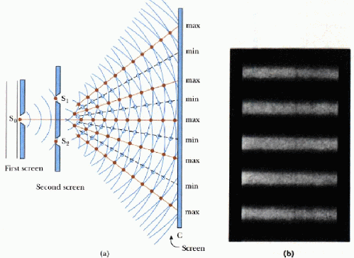In Young’s double slit experiment, as diagrammed to the right, light entered a slit in a screen (So) and diffracted to another screen with two slits (S1 and S2). Since the same diffracted light went through both slits, the light was **coherent** – i.e. the same phase. The light then diffracted through slits S1 and S2 and the interference pattern was observed on a distant screen. Antinodes appear as **bright fringes** and nodes appear as **dark fringes**.

# Interference equations

There are two basic equations that we use in the context of Young’s double slit experiment. The following diagram defines the variables.

x

❑

d

(distance between slits)

L (distance from slits to viewing screen)

5

4

3

2

n = 1

Bright fringes

(distance from the central maximum to the node or antinode of interest)

(angle from the centre line to the node or antinode of interest)

If we know the distance between the slits (d) and the angle () from the centre line to the fringe of interest (1st fringe (n=1), 2nd fringe (n=2), etc.), we can calculate the wavelength () using

 this equation is **always** valid for any angle

If we are given the distance to the screen (L) and the distance from the central maximum to the fringe of interest (x), a useful, but limited, second equation is



this equation is valid **only** for small angles (<10o) or when x is much smaller than L (x<<L)

These equations are for bright fringes. If we are interested in the **dark fringes** we **subtract ½ from n**.

# Derivation of interference equations (optional)

❑

Q

R fringe location

S central bright fringe

A

B

C

x

❑

d

L

path difference

Consider the following diagram of a double-slit experiment.

Diffracted light waves from points A and B meet and interfere with each other at point R. The distances from the two sources of diffracted waves and point R are and . The type of interference that occurs at R depends on the path difference from the sources. The **path difference** to R is . If  is a whole number multiple of a wavelength (n where n = 1, 2, 3,…) constructive interference will result.

∴  = n

We note that ΔABC is similar to ΔQRS and ∠C and ∠S are 90o. From ΔABC we get



since  and 

 (1)

rearranging we get our first equation



To derive our second equation we note that from ΔQRS we have the relationship



since  and 

 (2)

In order to relate equations (1) and (2) we note that for small angles of  (0o to 10o) the tangent and sine are nearly the same value (try it in your calculator)

**sin  ≅ tan ** for <10o

Therefore



rearranging this equation gives us our second useful formula



# Using the double-source interference equations

The equations that were derived in the previous section are:

These equations are on your formula sheet.

These equations may be made from the formula sheet by subtracting ½ from n.



where:

● wavelength (m)

❑ angle from central line to fringe

n fringe of interest

L distance from slits to screen (m)

x distance from central bright fringe to nth fringe (m)

d distance between slits (m)

An interference pattern is produced through two slits which are 0.045 mm apart using 550 nm light. What is the angle to the 4th bright fringe from the central line?



d = 0.045 x 10-3 m

n = 4

● = 550 x 10-9 m

A student doing Young’s experiment finds that the distance between the central bright fringe and the seventh nodal line is 6.0 cm. If the screen is located 3.0 m from the two slits, whose separation is 220 m, what is the wavelength of the light?



x = 0.060 m

L = 3.0 m

d = 220 x 10-6 m

n = 7

● = ?



An interference pattern is formed on a screen when a helium-neon laser light ( = 632.8 nm) is directed through two slits. If the slits are 43 m apart and the screen is 2.5 m away, what will be the separation between adjacent nodal lines?

When a question asks for the separation between nodes or antinodes, set n = 1 and use the constructive interference equation. For small angles the fringes are all the same distance apart, whether they are bright or dark.



x = ?

L = 2.5 m

d = 43 x 10-6 m

n = 1

● = 632.8 x 10-9 m

# Practice problems

1. A slide containing two slits 0.10 mm apart is 3.20 m from the viewing screen. Light of wavelength 500 nm falls on the slits from a distant source. How far from the centre line will the 9th bright fringe be? How many bright fringes are possible?

(0.144 m, 200)

2. In Young's experiment, the two slits are 0.04 mm apart and the screen is located 2.0 m away. The third order bright fringe is displaced 8.3 cm from the central fringe.

A. What is the frequency of the monochromatic light? (5.4 x 1014 Hz)

B. Where will the second dark fringe be located? (4.15 cm)

# Hand-in assignment

1. Light of frequency 6.0 x 1014 Hz is incident on a pair of straight parallel slits which are 5.0 x 10-5 m apart. Antinodal lines are produced in the region beyond the slits. What is the maximum number of antinodal lines in the interference pattern on either side of the central maximum? (Hint, what angle would the last antinode occur at?) (100)
2. Yellow light of wavelength 615 nm is incident on a double slit where slits are 1.3 mm apart. At what angle will the fifth order antinodal line appear? (0.14o)
3. How many antinodal lines can theoretically exist in an interference pattern on either side of the central maximum when radiation of 555 nm passes through slits which are 0.10 mm apart? (180)
4. Light of frequency 6.09 x 1014 Hz is incident on a pair of straight parallel slits and produces an interference pattern on a screen 7.00 m away. If the fringe spacing on the screen is 2.50 cm, determine the distance between the slits. (0.138 mm)
5. Light of frequency 4.8 x 1014 Hz is incident on a pair of straight parallel slits where the slits are 0.16 mm apart. It creates an interference pattern on a screen 8.0 m away. What is the distance from the centre of the pattern to the fourth bright line? (0.13 m)
6. A flat observation screen is placed at a distance of 4.5 m from a pair of slits. The separation on the screen between the central bright fringe and the first order bright fringe is 0.037 m. The light illuminating the slits has a wavelength of 490 nm. Determine the slit separation. (6.0 x 10-5 m)
7. In a Young’s double slit experiment the separation between the central bright fringe and the first order bright fringe is 2.40 cm for 475 nm light. Assuming that the angles that locate the fringes on the screen are small, find the separation between fringes when light has a wavelength of 611 nm. (3.09 cm)
8. In a Young’s double-slit experiment, the angle that locates the second-order bright fringe is 2.0o. If the slit separation is 3.8 x 10-5 m, what is the wavelength of the light? (6.6 x 10-7 m)
9. Red light of wavelength 600 nm passes through two parallel slits. Nodal lines are produced on a screen 3.0 m away. The distance between the first and tenth nodal lines is 5.0 cm. What is the separation of the slits? (3.24 x 10-4 m)
10. In an interference experiment, red light with a wavelength of 6.0 x 10-7 m passes through a double slit. On a screen 1.5 m away, the distance between the 1st and 11th dark bands is 2.0 cm.

a) What was the separation between the slits? (4.5 x 10-4 m)

b) What would the spacing be between adjacent nodal lines if blue light (450 nm) were used? (1.5 x 10-3 m)

1. In an interference experiment, describe and explain what the effect on the fringe spacing would be for the following situations:

a) If the light was changed from monochromatic red to monochromatic blue?

b) If the light was changed from monochromatic blue to white?

c) If the slit separation was decreased to half its original value?

d) If the screen was moved to half its original distance?